Different algorithm for calculating Salary.

|  |  |
| --- | --- |
|  |  |
|  |  |

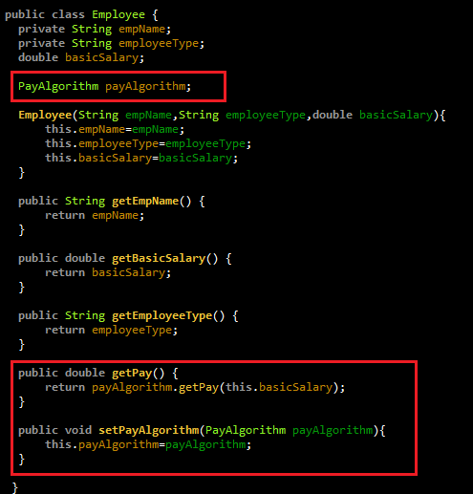

This is the final code which is dynamically specify PayAlgorithm at run time.